Name: ___________________________________
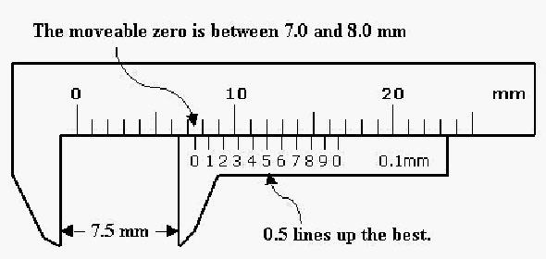
Calipers Lab – Physics

Objectives: Determine the volume of a cylinder using a variety of tools. Evaluate the advantages and disadvantages of each method.

Review:
Volume of a cylinder = π r² ∙ h = (½ d)² π ∙ h

Pre-Lab:
Read this short overview of how to use the Vernier caliper.
http://www.miniphysics.com/how-to-read-a-vernier-caliper.html
View the animation at http://www.stefanelli.eng.br/en/en-vernier-scale-nonius.html
The animation is near the bottom of the page. It shows you how to read the scale and record a measurement to the tenth of a millimeter.

Materials: ruler, Vernier caliper, micrometer caliper, graduated cylinder, water, metal cylinders

Procedures:
- Set up the data tables on your own paper.
- Choose a cylinder.
- Record the cylinder number (if it is a larger cylinder.)
- Use a ruler to get height and diameter of the cylinder. Calculate the volume.
- Use the Vernier caliper to get the height and diameter. Calculate volume.
- Use the micrometer caliper to get the diameter. (Use the Vernier caliper for the height.) Calculate volume of each object.
- Use water displacement and a graduated cylinder to measure the volume of each cylinder.
- Record answers to the discussion questions and evaluation on your own paper.

Data:
Object 1: small cylinder

Cylinder# | Tool 1 (ruler) | Tool 2 (caliper) | Tool 3 (micrometer) | Tool 4 (grad cylinder)
Diameter |  |  |  | N/A
Height |  |  |  | N/A
Volume

Object 2: longer cylinder

Cylinder # | Tool 1 (ruler) | Tool 2 (caliper) | Tool 3 (micrometer) | Tool 4 (grad cylinder)
Diameter |  |  |  | N/A
Height |  |  |  | N/A
Volume
Show your work for finding the volume of the first cylinder using the ruler measurements in the space below:

Known values
Equation
Setup and Solve
(circle your answer)

Analysis:
- Show how you would convert a volume of 2550 mm³ to cm³. (Set up a dimensional analysis problem with the correct conversion factor.)

2. How does your graduated cylinder measurement using the displacement method compare to your calculation for volume using the caliper measurements? Explain the reasons for the differences in your answers.

3. Which tool is most precise / least precise?

4. Which tool do you feel is most accurate / least accurate? Explain.

Error Analysis: Read the information about error analysis at: http://physics.appstate.edu/undergraduate-programs/laboratory/resources/error-analysis

List the types of errors that would be possible with each method.

Ruler:

Calipers:

Micrometer:

Graduated Cylinder:

Conclusion:
Discuss the advantages and disadvantages of each measurement technique for finding volume.

